Name __________________________

Date _________________

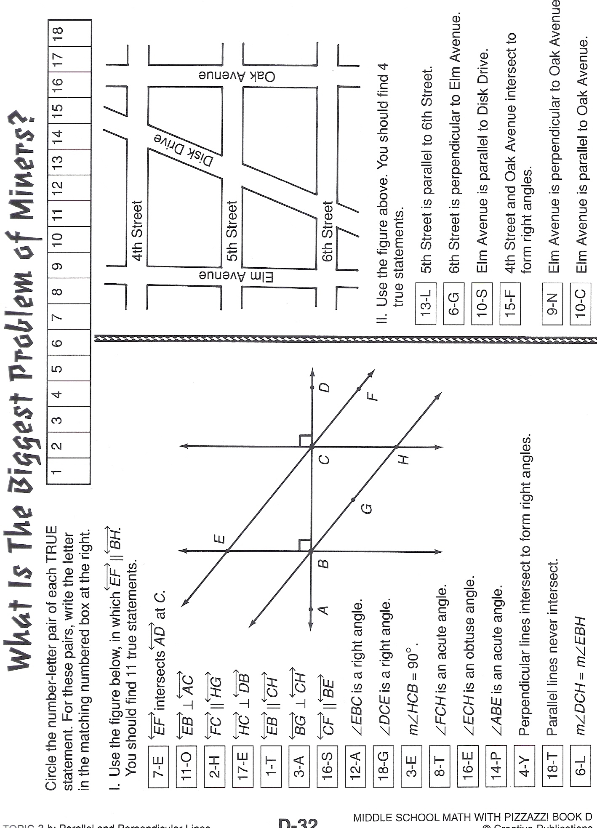
Parallel and Perpendicular Lines

In class, we proved that alternate interior angles are congruent. The proof for why
∠3 = ∠7 could be written using a two-column proof. One column are all of your statements. The other column contains the reasons for why your statements are true. The proof for why ∠3 = ∠7 that we discussed in class is shown in two-column form below:

Statements Reasons
8
7
6
5
4
3
2
1

m(∠3) = m(∠1) they are corresponding angles

m(∠1) = m(∠7) they are vertical angles

m(∠3) = m(∠7) they are both equal to m(∠1)
(transitivity)

- Refer to the diagram above where m || n. Use a two-column proof similar to the one above to prove that m(∠2) = m(∠6).

- We proved that alternate interior angles are congruent. Are alternate exterior angles congruent? Refer to the diagram above where m || n. Use the two-column proof format to try to prove that m(∠1) = m(∠5). ∠1 and ∠5 are called alternate exterior angles because they are on opposite sides of the transversal and on the outside of the parallel lines.

- Use the two-column proof format to try to prove that m(∠4) = m(∠8). ∠4 and ∠8 are called alternate exterior angles because they are on opposite sides of the transversal and on the outside of the parallel lines.


